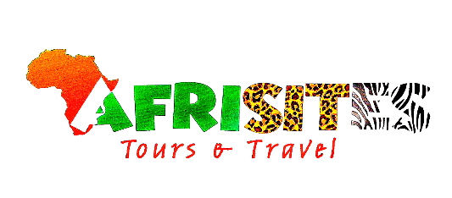
This trip is organized to visit the mountain gorillas in the southwestern part of Uganda, Bwindi Impenetrable Forest National Park. Accommodation includes lodges with private toilets and showers with hot running water on a full board basis. This trip is suitable for travelers who want to combine a gorilla experience with a typical wildlife safari in East Africa.

Route
Start & End Day 1Day 2Day 3
Uganda
Start | Entebbe (Day 1)
Day 1 | Kampala (City)
Day 2 | Bwindi Impenetrable NP (Gorillas)
Day 3 | Kampala (City)
End | Entebbe (Day 3)

Tour Features

Mid-range tour
- This mid-range tour uses lodges.

Private tour
- This tour will be organized exclusively for you. However, wildlife viewing activities are run by the lodges/camps and will be shared with others.

Can start any day
- If availability permits, this tour can start on any day.

Can be customized
- You can request changes to this tour.

Suitable for solo travellers, groups of six to eight people.
- Solo travellers can book this private tour.
- Groups can book this safari.

Minimum age of 15 years
- The minimum age for this tour is 15 years.

Activities & Transportation
- Activities: gorilla trekking

- Getting around: open-sided 4x4 vehicle & pop-up roof 4x4 vehicle

- A transfer from and back to the airport is included

Accommodation & Meals
- Accommodation before is before the tour starts is offered but can be arranged at the end for an extra cost.
- Day Accommodation Meals
Karibu BB Suites Mid-range lodge in Entebbe
- 1-2-3
Rushaga Gorilla Lodge Mid-range lodge just outside Rushaga (Bwindi Impenetrable NP)

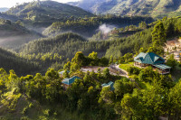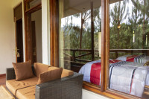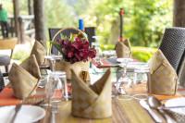

+40Photos
All Meals Included
- 3 End of tour
(No accommodation) All Meals Included

Day by Day

Arrival
- You'll be collected from the airport, accommodation and transfer from the airport before the tour starts is catered for.

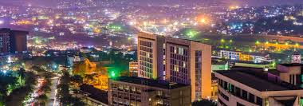

Day 1 Pick Up from Kampala and Transfer to Bwindi Forest

Time | Activity
07:00 AM | Pick-up from your hotel in Kampala or Entebbe by your guide
08:00 AM | Scenic drive south-west via Masaka-Mbarara highway
11:00 AM | Equator Stopover (Kayabwe): Stretch your legs, enjoy a short photo session and grab refreshments
01:00 PM | Lunch en route in Mbarara (Igongo Cultural Centre)
03:00 PM | Resume journey through the scenic countryside: tea plantations, banana farms, rolling hills
06:30 PM | Arrive at Bwindi Impenetrable National Park
07:00 PM | Check-in at Rushaga Gorilla Lodge (Mid-range, Full-Board)
Evening | Dinner, safari briefing and overnight rest

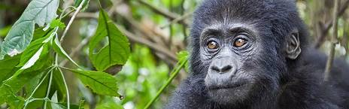

Day 2

Gorilla Trekking Safari and Batwa Experience
Time | Activity
06:00 AM | Early breakfast at the lodge
07:00 AM | Transfer to the park headquarters for briefing
08:00 AM | Start your guided gorilla trek
12:30 PM–01:00 PM | Enjoy your packed lunch in the forest clearing
02:30 PM | Return from the forest, refresh at the lodge
03:30 PM | Embark on a guided Batwa cultural experience
06:30 PM | Return to the lodge, relax and enjoy a hearty dinner
Main Activity | Gorilla Trekking & Batwa Cultural Tour
Accommodation | Rushaga Gorilla Lodge (Mid-range)
Meal Plan | Breakfast, Lunch, and Dinner


Day 3

Transfer Back to Kampala
Time | Activity
06:30 AM | Early breakfast and checkout
07:30 AM | Begin the return journey to Kampala or Entebbe
01:00 PM | Stop for lunch in Mbarara
05:00 PM | Short rest at the Equator Monument
07:30 PM | Arrive in Kampala or Entebbe for drop-off. Optionally proceed to Entebbe International Airport for evening departures
Main Destination | Kampala / Entebbe
Accommodation | None (End of Tour)
Meal Plan | Breakfast & Lunch

Important to Know
- Rates are per person and exclude the international flight from/to your home country.
- This tour accepts children who are 15 years and older.

Rates Per Person
Start dates | Solo1 room | 2 people1 room | 3 people2 rooms | 4 people2 rooms | 5 people3 rooms | 6 people3 rooms
Jan 1, 2026 - Dec 31, 2026 | $1,640 | $1,530 | $1,430 | $1,330 | $1,330 | $1,330

Included
- Park fees(For non-residents)
- Gorilla permits(One per person, non-resident)
- All activities(Unless labeled as optional)
- All accommodation(Unless listed as upgrade)
- A professional driver/guide
- All transportation(Unless labeled as optional)
- All Taxes/VAT
- Roundtrip airport transfer
- Meals(As specified in the day-by-day section)
- Drinks(As specified in the day-by-day section)

Excluded
- International flights(From/to home)
- Additional accommodation before and at the end of the tour
- Tips(Tipping guideline US$10.00 pp per day)
- Personal items(Souvenirs, travel insurance, visa fees, etc.)
- Government imposed increase of taxes and/or park fees

